
Services for Students with Disabilities
2019-20 Annual Report



University of Wisconsin System
2019-20 Annual Report – Services for Students with Disabilities

TABLE OF CONTENTS
Annual report committee 2
Disability/accessibility services directors 2
Forward 4
Introduction 5
Total Enrolled Students with Disabilities 5
Table 1: Total Enrolled Students with Disabilities, 2019-20 5
Primary Disability Categories 6
Figure 2: Percentage of Students by Primary Disability, 2019-20 7
Figure 3: Number of Students by Primary Disability, Six-Year Trends (1) 8
Figure 4: Number of Students by Primary Disability, Six-Year Trends (2) 9
Personnel/Staffing 10
Table 2: Disability Services Staffing and Caseload 10
Figure 5: Access Coordinator Caseload 11
COVID-19 Impacts on Services During Spring 2020 13
Conclusion and Future Directions 14
Reference 15
Appendix 1: Students with Disabilities by Campus, Six-Year Trends 16
Appendix 2: Primary Disability Categories by Campus, 2019-20 17
Appendix 3: Primary Disability Categories, Six-Year Trends 18
Appendix 4: Enrollment and Staffing Data by Campus, 2019-20 19

Annual report committee
Mari Magler, UW-Madison
Assistant Dean/Director, McBurney Disability Resource Center
Ann Murphy, UW-Stout
Director, Disability Services
Alicia Reinke-Tuthill, UW-River Falls
Manager of Ability Services
Vicky Thomas, UW-Eau Claire
Director, Services for Students with Disabilities and Project AIM (Ability in Motion)
John Achter, UW System Administration
Student Behavioral Health Coordinator, Office of Student Success

Disability/accessibility services directors
Vicky Thomas, UW-Eau Claire
Director, Services for Students with Disabilities and Project AIM (Ability in Motion)
Lynn Niemi, UW-Green Bay
Director, Student Accessibility Services
Andrew Oliver, UW-La Crosse
Director, The ACCESS Center
Mari Magler, UW-Madison
Assistant Dean/Director, McBurney Disability Resource Center
Jonathan Broskowski, UW-Milwaukee
Interim Director, Accessibility Resource Center
Holly Ludwig Callaghan, UW-Oshkosh
Accessibility Coordinator, Dean of Students Office/Accessibility Center
Renee’ Sartin Kirby, UW-Parkside
Director, Disability Services
Brenda M Sunderdance, UW-Platteville
Assistant Director, Services for Students with Disabilities
Alicia Reinke-Tuthill, UW-River Falls
Manager of Ability Services
Andy Held, UW-Stevens Point
Director, Disability and Assistive Technology Center
Ann Murphy, UW-Stout
Director, Disability Services
Mickey Fitch-Collins, UW-Superior
Interim Executive Director of Student Success & Coordinator of Disability Support Services
Debbie Reuter, UW-Whitewater
Interim Director, Center for Students with Disabilities
System Liaison:
John Achter, UW System Administration
Student Behavioral Health Coordinator, Office of Student Success



Forward
Students with disabilities have always been present on college campuses and have contributed to the higher education environment in countless meaningful ways. But the path toward pursuing a degree is not always easy for these students, as many aspects of the educational environment are not readily accessible. With the passage of key pieces of anti-discrimination legislation in 1973 and 1990, the need for professionals ensuring and supporting equal access for disabled students was elevated to a national priority. This annual report seeks to highlight the important work of disability services professionals within the University of Wisconsin System in supporting students and advocating for equal access on their campuses.
It is fitting in this 30th anniversary year of the Americans with Disabilities Act (ADA) that the UW System Annual Report of Services for Students with Disabilities gets a fresh look. Coordinators of Services for Students with Disabilities (CSSDs) have witnessed significant changes in their work with students since the ADA Amendments Act (ADAAA) of 2008 broadened the definition of the term "disability" in ways that made it easier for individuals to establish that they have a disability covered by the ADA. In addition, increased awareness and prevalence of certain disability categories (such as psychological, chronic health, and autism-spectrum) have shifted both the nature of the population that disability services offices serve and the types of barriers to equal access that need to be addressed.
This year’s report seeks to begin a new direction by highlighting some of these recent trends and providing more explanation and nuance to the work being done with and for students with disabilities. The present report focuses primarily on trends in the number of students seeking services, the types of disabilities presented, and the level of staffing available to support and advocate for equal access. Additionally, it comments on the ways in which the COVID-19 pandemic impacted disability services work in Spring 2020.
Future reports plan to build on this foundation by adding more in-depth information on the nature and range of accommodations required to improve access, and a sense of the time and effort required by staff to assist students in achieving their access needs.
I’m honored to be working with such a passionate and committed group of professionals to help them better tell their story as well as the story of students whose potential is realized when provided with adequate resources to bring about equitable living and learning environments.


John Achter
UW System Administration
Student Behavioral Health Coordinator, Office of Student Success
UW System Liaison to Coordinators of Services for Students with Disabilities

Introduction
This annual report is prepared by the Coordinators of Services for Students with Disabilities (CSSDs) within UW System, in accordance with the UW System Board of Regents Policy 14-10: Nondiscrimination on Basis of Disability. The report represents data gathered by the campus offices designated to collect student disability documentation, identify reasonable accommodations that ensure access to programs and activities, and provide services according to Section 504 and 508 of the Rehabilitation Act (1973), the Americans with Disabilities Act (ADA, 1990; ADAAA, 2008), and UW System Policy.
The CSSD group meets regularly to discuss disability services, trends, and plans for addressing issues. All UW System four-year institutions collect data on services provided to students based on agreed-upon data collection and reporting guidelines for consistent aggregate reporting and comparison purposes. Most campuses collect data with a database designed to manage multiple aspects of providing services to students with disabilities. Two campuses lack these resources and track data manually through use of Excel spreadsheets or other means.
This year, an Annual Report Committee was formed to review and suggest changes to the content and format of the report. As noted in the Forward, we hope each iteration of the annual report will provide additional information to better tell the story of students with disabilities and the work being done to make their living and learning environments more accessible.

Total Enrolled Students with Disabilities
As shown in Table 1, across UW System campuses in 2019-20, just over 10,000 students with disabilities were affiliated with disability services offices. This represented 6.2% of total UW System enrollment. Two hundred-twenty-five (225) of those students were identified as veterans. This is believed to be an underestimate due to inconsistencies in the way centers identify veteran status.

Table 1: Total Enrolled Students with Disabilities, 2019-20
Total number of students enrolled¹ with disabilities who are eligible for services | Number of veterans within total | Total institutional enrollment² | Percentage of student population with registered disabilities
10,015 | 225 | 161,955 | 6.2%
¹Summer 2019, Fall 2019, and Spring 2020
²Fall 2019, 10th day headcount (including branch campuses, if applicable)
The past six years have seen a steady increase in the number of students affiliating with disability services offices. As displayed in Figure 1 (see p. 6), during academic year 2014-2015 a total of 7,169 students with disabilities affiliated with these offices across UW System campuses. In 2019-2020 this total had increased to over 10,000 students, representing 48% growth in UW students with disabilities requesting accommodations. It is notable that, despite many campuses experiencing flat or even decreasing enrollment over this time span, the number of students with disabilities seeking accommodations continues to grow. Complete campus-by-campus trends can be found in Appendix 1.
Figure 1: Total Enrolled Students with Disabilities, Six-Year Trend
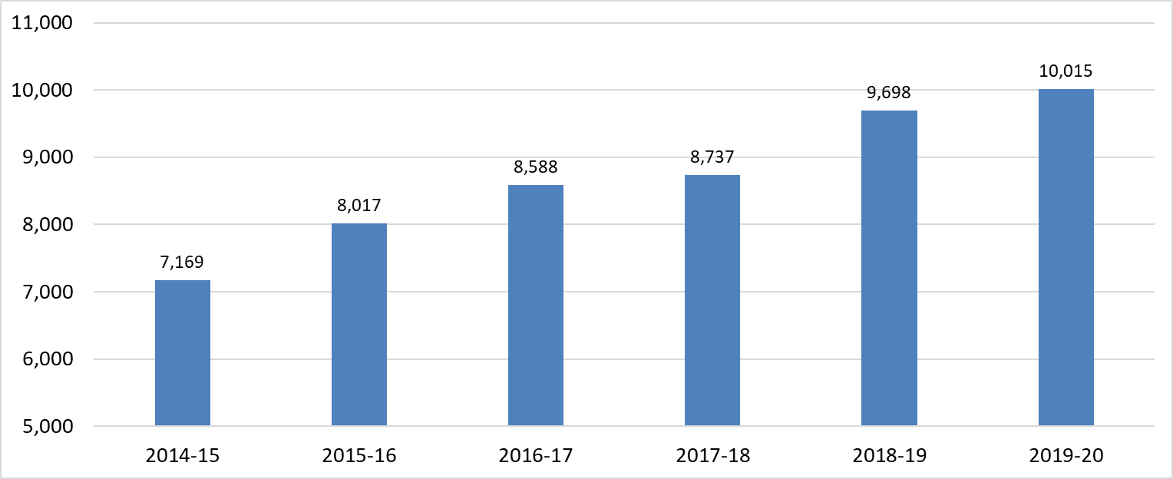
Image Description: Bar graph identifying the total number of enrolled students with disabilities across UW System campuses over a 6-year period. 2014-2015 (7,169), 2015-2016 (8,017), 2016-2017 (8,588), 2017-2018 (8,737), 2018-2019 (9,698), 2019-2020 (10,015).

Primary Disability Categories
UW System campuses collect primary disability information to identify trends in major recognized disability categories. Understanding these trends is vital in developing appropriate services, resources, and training. Currently, the following 11 primary disability categories are tracked across the System:
- Attention Deficit Disorder/Attention Deficit Hyperactivity Disorder (ADD/ADHD)
- Autism Spectrum
- Brain Injury
- Health Condition
- Hearing Disability
- Learning Disability
- Mobility Disability
- Psychological Disability
- Temporary Disability
- Visual Disability
- Other Disability
The pie chart in Figure 2 (see p. 7) illustrates the relative percentages of these disability categories among the student population seeking disability services in 2019-20. Campus-by-campus breakdowns of primary disability categories for the past six years can be found in Appendix 2.

Figure 2: Percentage of Students by Primary Disability, 2019-20
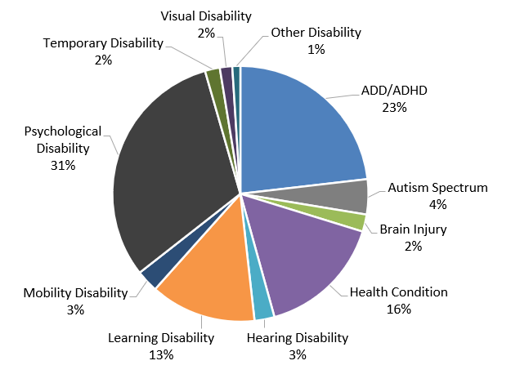
Image Description: Pie chart displaying Percentage of Students by Primary Disability. ADD/ADHD 23%, Autism Spectrum 4%, Brain Injury 2%, Health 16%, Hearing 3%, Learning 13%, Mobility 3%, Psychological 31%, Temporary Disability 2%, Visual 2%, Other 1%.
The relative percentage of the 11 disability categories tracked by disability services offices has shifted over the last decade. As displayed in Figures 3 and 4 (see pp. 8 and 9), over the span of six years, certain primary disability categories have grown significantly in number, while others have remained relatively stable. Among the top four disability categories in Figure 3, the most notable change has been in the number of students with Psychological Disabilities, which increased 110% between the 2014-2015 and 2019-20 academic years. Notably, in 2016-2017 Psychological Disabilities surpassed ADD/ADHD as the most common reason students with disabilities affiliate with and seek out accommodations from disability services offices. This trend is consistent with population health surveys among college students and reports from university counseling centers documenting significant increases in mental health diagnoses such as anxiety and depression. The trend has no single cause but has been attributed to a variety of factors including increased college pressures (such as selectivity and rising costs), social media influences on students’ lives, and decreased stigma in help-seeking, among other reasons.
The categories of Health Conditions (+80%) and ADD/ADHD (+29%) also continued to grow in number over this time period. The growth in Health Conditions can be at least partially explained by the fact that some chronic health conditions were not covered under the ADA prior to the ADA Amendments Act in 2008. This category includes disabilities that are intermittent in nature or fluctuate with the exacerbation of symptoms, such as migraines, gastrointestinal disorders, chronic pain, etc. The steady rise in ADHD has been attributed to increasing recognition and detection of students who experience challenges with attention and focus (with or without hyperactivity) and the recognition that many of these harder-to-detect symptoms of ADD/ADHD persist into adulthood.

Figure 3: Number of Students by Primary Disability, Six-Year Trends (1)
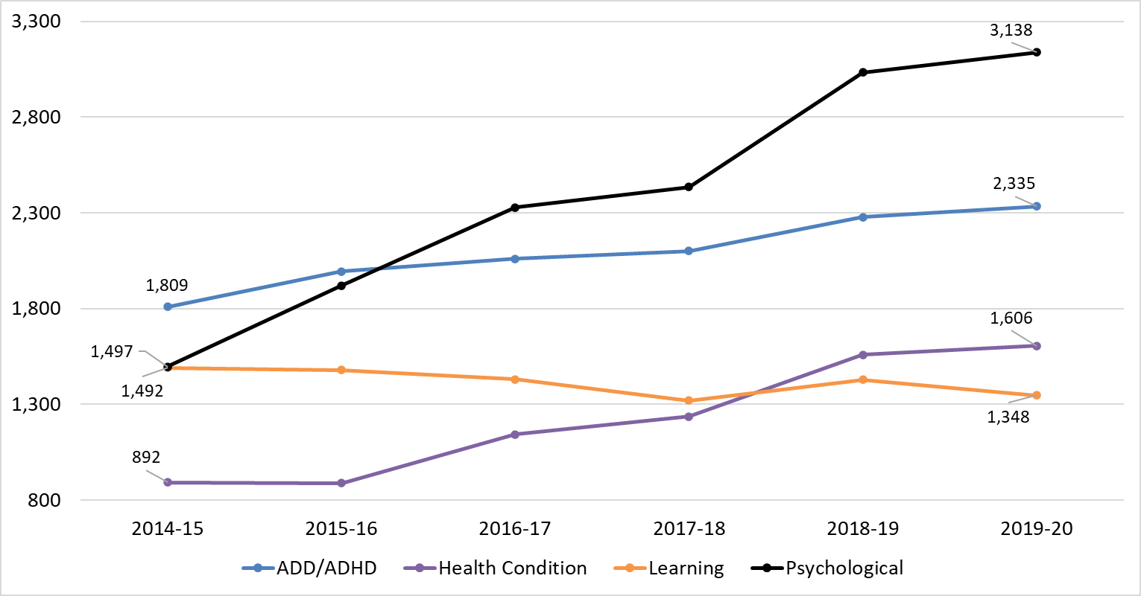
Image Description: Line graph displaying change from 2014-15 to 2019-20 in the number of students in the four most common disability categories: ADD/ADHD (2014-15: 1,809; 2019-20: 2,335), Health Condition (892; 1606), Learning (1,492; 1,348), Psychological (1,497; 3,138).

Also of note is the decreased number of students identifying with a Learning Disability (LD; -10%). We do not believe this represents a true decline in the number of students with learning disabilities; rather, we suspect that the trend toward “Response to Intervention (RTI)” approaches in K-12 educational settings has resulted in the change. Since around 2004, RTI approaches—which focus on providing informal accommodations such as extended time for exams and increased tutoring support, without requiring testing for disabilities—have become increasingly predominant. If a student does well with the informal interventions in the K-12 setting, the student would not come to the post-secondary environment with an LD diagnosis. Some of these students begin to struggle in the college environment as course demands rise, prompting them to seek out disability services offices for referrals to receive professional assessments that might formally identify their learning challenges and qualify them to request accommodations.
Among less commonly reported disability categories in Figure 4 (see p. 9), Autism Spectrum (+33%) showed the greatest increase, Brain Injuries (+11) showed the most fluctuation, and all other categories showed modest to little change. Perhaps most notable in this group is the increase in students identifying on the Autism Spectrum as their primary disability—a trend that is likely to persist given that the Center for Disease Control has documented a sharp rise in Autism Spectrum Disorder prevalence in children in the past 20 years—from 1 in 150 in the year 2000, to 1 in 54 in 2016 (https://www.cdc.gov/ncbddd/autism/data.html). Disability professionals have become increasingly familiar with the unique needs of students on the Autism Spectrum in the post-secondary environment and will need to continue staying on top of how to best serve this student population.

Figure 4: Number of Students by Primary Disability, Six-Year Trends (2)
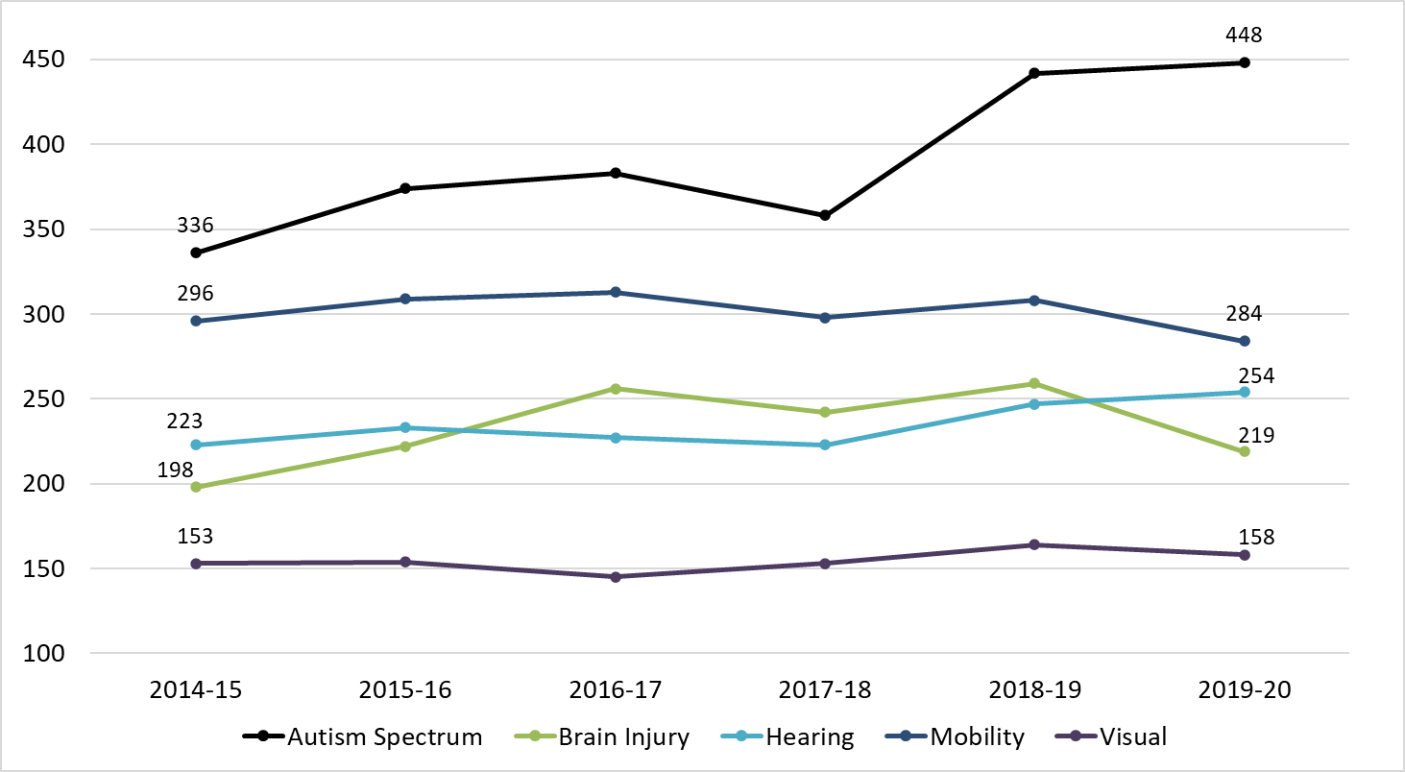
Image Description: Line graph displaying change from 2014-15 to 2019-20 in the number of students in the five less-common disability categories: Autism Spectrum (2014-15: 336; 2019-20: 448), Brain Injury (198; 219), Hearing (223; 254), Mobility (296; 284), Visual (153; 158).

Because of the trends noted above, the work of disability services professionals has become increasingly complex in the past decade, as the combination of higher numbers of students with shifting disabilities has greatly expanded the range of supports needed to ensure equitable access. For example, accommodations for students with psychological disabilities or health conditions may include requests for modified or flexible class attendance, single-room requests in housing, private bathrooms, dietary exemptions for severe allergies, or emotional support animals. Autistic students, who experience deficits in executive functioning and social communication, may require interventions extending to social situations, organizational strategies, and prioritizing tasks, in addition to more typical classroom accommodations.
Because the disability categories leading to these accommodations are often “invisible” to casual observers, and the fact that many of the accommodations were not requested or recommended until relatively recently, the accommodation process often requires additional time and effort to implement effectively. Disability services professionals dedicate considerable time to case management, consultation, training, and advocacy with faculty, staff, and the campus community at large to ensure accommodations are effectively implemented.
In addition, the increasing complexity of accommodation requests can impact the front end of the accommodation process, as it calls for documentation that clearly articulates diagnoses, the frequency and severity of symptoms, and the functional deficits that create barriers to the living and learning environment. Attaining adequate documentation is an interactive process that often takes time and, in the interim, offices must decide how far they will extend temporary or conditional accommodations to students while working together to obtain required documentation.
A final impact worthy of mentioning about evolving disability and accommodation trends is that parents and guardians have become more involved in advocating for their disabled students, with expectations that parallel the services received in the K-12 system. This also puts strains on staff as they devote more time to working with students and parents to understand the range of support and assistance that is possible in the university environment.
Given all these evolving factors, we hope to share more data on the full range of accommodations and their impact on providing services in the 2020-21 annual report.

Personnel/Staffing
As a result of the trends outlined in this report, disability services offices have taken on increasing numbers of students with increasingly complex accommodation requests, often without a comparable increase in staffing resources. Table 2 shows that a total of 79 Full-Time Equivalent (FTE) staff members are employed in disability services offices across the UW System. This total includes all staff employed within these offices: office program associates, assistive technology specialists, testing center coordinators, American Sign Language (ASL) interpreters, directors, and access coordinators.

Table 2: Disability Services Staffing and Caseload
Total Staff FTE | Access Coordinator FTE* | Average Caseload (Students Served/Access Coordinator FTE)* | Range of Average Caseload
79 | 32 | 310 | 132 to 795
*Amount of FTE staff devoted to access coordinator duties (if some staff split time between duties, this includes a best estimate of the amount of position time dedicated to this role)
Staffing levels and types of positions within disability services offices vary among UW campuses in the following ways:
- Some campuses have ASL interpreters employed by their unit; however, the interpreter works with a small number of deaf students due to the time-intensive nature of their work. Some campuses hire interpreters as vendors, and they are not included in the FTE.
- Some campuses have testing centers with a specific staff member who coordinates the mandated testing accommodations; on other campuses, all staff members share those duties.
- Staff members working with students with multiple needs devote a higher proportion of time providing and coordinating services for these students, compared with students whose disabilities require fewer accommodations.
The access coordinator role is central to the office since it facilitates the overall coordination of services for students, including reviewing eligibility, identifying barriers to access, developing and implementing accommodation plans, and ensuring interactive dialogue with students, instructors, and other university staff throughout the years of a student’s enrollment. A total of 32 FTE staff were dedicated to the role of access coordinator across the UW System in 2019-20, with an average caseload of 310 students. Figure 5 shows the campus-by-campus breakdown of access coordinator caseload numbers. Across all campuses, average caseloads range from 132 to 795 students. Note that campuses with similar overall student enrollment do not necessarily have the same average caseload for access coordinators. For example, UW-Stevens Point and UW-Platteville have similar enrollment, but access coordinators at UW-Platteville have an average caseload of 132, while staff in the same role at UW Stevens Point have an average caseload of 487.

Figure 5: Access Coordinator Caseload
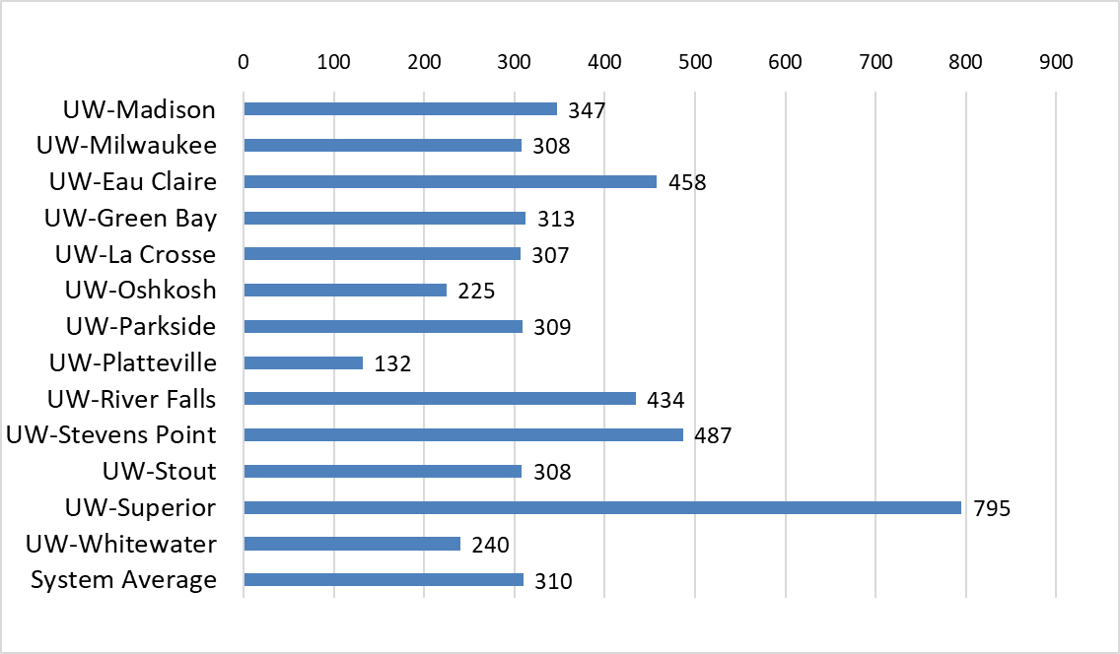
Image Description: Access Coordinator Average Caseload across UW System Campuses. UW-Madison 347, UW-Milwaukee 308, UW-Eau Claire 458, UW-Green Bay 313, UW-La Crosse 307, UW Oshkosh 225, UW-Parkside 309, UW-Platteville 132, UW-River Falls 434, UW-Stevens Point 487, UW-Stout 308, UW-Superior 795, UW-Whitewater 240, UW System Average 310.
It should be evident that the level of service that can be provided varies according to caseload size and the disability categories a staff member is working with. In general, access coordinators with lower caseload numbers can provide more individualized service, better monitor academic progress, and more fully engage in the interactive process with their students. Coordinators with larger caseloads have less time to review the effectiveness of accommodations and to intervene in situations where students may not be receiving approved accommodations. They may also need to leverage technology to a greater degree to serve the needs of students eligible for disability services, which can come at the expense of a more individualized interactive process.
To put these caseload numbers into some context, it can be helpful to review national trends. The Association on Higher Education and Disability (AHEAD) conducted a national survey of disability services staffing in 2017 (Scott, 2017, pp. 11-12; 21-22). In this national survey, respondents were asked how many students they work with during a typical semester, along with other questions about caseload assignment. While our data collection method differs slightly from this study, consider these key findings from the national report:
- The average number of students per caseload reported by respondents was 164.
- 63% of participants reported they work on an individual basis with 150 or fewer students.
- The most frequently reported number of assigned students or case load was 100 students.
- Almost half of participants (48%) indicated 100 students or fewer was an ideal number.
- A little over one-third (36%) of respondents reported ideal student numbers between 101-200.
- In addition to registered students, respondents reported interacting with prospective students ranging from 2 to 1400 students or visitors.
The Scott (2017) survey also revealed several trends that typify the current work of disability services professionals, including the following themes consistent with those reported by UW System campuses:
- A strong value and commitment to providing student-centered work and promoting accessible campuses.
- Agreement that the numbers of students registered with a disability resource office only captures a portion of each staff member’s student work. As one participant described, “I have approximately 350 students on my caseload, but I also interact frequently with prospective students or students who are in the process of registering with our office” (p. 11).
- Due to the case-by-case nature of the work, respondents emphasized the importance of being available quickly when a student identifies an access or disability-related issue.
- Over half of professionals (52%) reported they did not have adequate time for campus outreach, training, and consultation.
- Several respondents reflected on the challenges of maintaining staff well-being: “Having enough support in place to effectively address each student’s needs while considering staffs’ wellness would be ideal” (p. 21).
In the report’s conclusion, Scott (2017) states, “Many aspects of this work are decided on a case-by-case basis. As a field, we are quite familiar with the importance of this guiding principle. The patterns and trends described above provide a foundation for better understanding the factors that influence what constitutes a reasonable number of students for disability resource professionals who provide individual work with students.” (p. 22)
Even with differences in data collection methods, this national survey data suggests that many centers serving students with disabilities within the UW System may be operating below national averages. High caseload numbers can delay intake of new students and impact the level of service staff can provide to meet disabled students’ needs. Ultimately, this can impact the performance, retention, and graduation of students with disabilities. Disability services offices and campuses at large must remain diligent and prudent in providing mandated services according to the law, and continually review staffing and other resources to ensure this is being done well. In future reports, we hope to provide additional information to better understand the variety of staffing levels across UW System campuses and the impact they have on service levels and student outcomes.

COVID-19 Impacts on Services During Spring 2020
This 2019-20 report would be incomplete if it did not mention the impact of the COVID-19 pandemic. As the pandemic hit suddenly and interrupted campus operations in February/March 2020, disability services professionals experienced great changes and led efforts on their campuses to ensure students with disabilities received and maintained access to education. With the change to virtual and hybrid modes of instruction, some students with disabilities had more access to their coursework than they previously did, while others experienced new or increased challenges. Some students have long requested remote access to the learning environment as an accommodation—one that has often been denied on campuses dominated by in-person instruction. Now that all students, faculty, and staff have experienced working and learning in remote formats, we expect even more requests for remote learning options from students once campuses return to the norm of in-person instruction.
The shift to remote learning resulted in campuses proctoring far fewer accommodated exams in person, and significant spikes in demand for captioned media. Campuses working with Deaf and hard-of-hearing students had to work quickly to determine how to provide meaningful access through remote interpreting and captioning services—sometimes for in-person classes, and other times for classes that had a mix of students in person and on-line. In the realm of housing accommodations, some campuses saw an increase in requests for emotional support animals, single-room assignments, and releases from student housing contracts so students could return home.
Additionally, students with disabilities reported the following impacts with the sudden and unexpected shift to remote learning:
- Lack of or unstable internet access
- Using cellphones to do course work due to lack of computer or internet access
- An increase in mental health conditions and symptoms, including isolation, loneliness, and anxiety
- A sense of disconnection with faculty and peers, lack of access to instructors at times, and difficulty finding and maintaining a sense of order and organization for their coursework
- Difficulty with newly adopted exam proctoring software, including the experience of being interrupted multiple times during an exam for disability or accommodation related behaviors

Some things became more accessible during the pandemic:
- Remote access to class, tutoring options, advisors, and other campus professionals. Many students reported that doing meetings from home was more accessible for them. Some centers reported a higher attendance rate for certain types of appointments (such as study skills assistance) than typically experienced in person.
- Flexibility regarding attendance. For courses with synchronous components, attendance flexibility is an accommodation often considered to address disabilities that are intermittent or fluctuating in nature. The options of accessing lectures remotely or from recordings gives students the ability to stay involved with their courses while also managing their health-related needs.
- Flexibility regarding assignment deadlines. Many instructors allowed more flexibility for students in general because of the pandemic, which benefitted students with disabilities.
The pandemic clearly had a profound impact on the work, school, and social lives of students, faculty, and staff. Given that the pandemic is persisting into the 2020-21 academic year, we will report further on the impacts in next year’s annual report.

Conclusion and Future Directions
This report makes it very clear that the landscape of disability services in higher education has been changing, and that disability services professionals across the UW System are working exceptionally hard to adapt. With more students identifying with disabilities, the types of disabilities shifting, accommodation requirements becoming more complex, and staffing resources stretched thin, disability services offices are often strained to provide the level of service required to achieve equal access for disabled students. They have needed to become creative by using technology to establish greater efficiencies and modifying practices to ensure essential service levels are maintained. Some of these choices, however, come at a cost to both students and staff when resources are not adequate to meet demands. Disability services professionals are creative and resilient, and they will continue to find creative solutions to meet the needs of students. They also hope that campus and System administrators will use information from this annual report and from individual campuses to assess whether adequate resources are being allocated to the efforts.
We believe this report provides a good snapshot of what our work looked like in 2019-20 and in the few years preceding it. In future reports, we hope to paint a broader picture of disability services work by sharing additional information. Some of the additions under consideration include:
- Typical wait-times for students seeking services
- Data on students who have more than one documented disability
- The types of accommodations implemented in various campus environments (for example, classroom, housing, and dining)
- The variability in workload demands based on disability type and accommodation needs of students
- The impact our work has on student outcomes
The last item above, student outcomes, is of course the most critical metric for all of us involved in higher education. Does the work we do lead to increased student retention, graduation rates, and positive life outcomes? We believe it can and does, and we look forward to continuing to collect and share the information necessary to help us and our stakeholders track, evaluate, and continually improve our efforts toward these ultimate goals of student success.

Reference
Scott, S. (2017). Disability resource professionals and their individual work with students. Huntersville, NC: Association on Higher Education and Disability (AHEAD).

Appendix 1: Students with Disabilities by Campus, Six-Year Trends

 | Total Students
Institution | 2014-15 | 2015-16 | 2016-17 | 2017-18 | 2018-19 | 2019-20 | Total Change | % Change
UW-Madison | 1361 | 1660 | 1,946 | 2,220 | 2,622 | 2,932 | 1,571 | 115%
UW-Milwaukee | 804 | 883 | 711 | 627 | 971 | 1,230 | 426 | 53%
UW-Eau Claire | 416 | 495 | 529 | 576 | 662 | 664 | 248 | 60%
UW-Green Bay | 226 | 239 | 285 | 300 | 323 | 344 | 118 | 52%
UW-La Crosse | 348 | 445 | 586 | 644 | 721 | 748 | 400 | 115%
UW Oshkosh | 299 | 264 | 276 | 491 | 517 | 225 | -74 | -25%
UW-Parkside | 241 | 335 | 320 | 256 | 368 | 309 | 68 | 28%
UW-Platteville | 306 | 360 | 376 | 377 | 409 | 423 | 117 | 38%
UW-River Falls | 304 | 329 | 352 | 362 | 402 | 434 | 130 | 43%
UW-Stevens Point | 534 | 554 | 599 | 638 | 756 | 730 | 196 | 37%
UW-Stout | 721 | 798 | 862 | 564 | 682 | 616 | -105 | -15%
UW-Superior | 70 | 111 | 130 | 176 | 131 | 159 | 89 | 127%
UW-Whitewater | 936 | 951 | 1,056 | 1,069 | 1,134 | 1,201 | 265 | 28%
UW Colleges¹ | 603 | 593 | 560 | 437 | NA | NA | NA | NA
Total | 7,169 | 8,017 | 8,588 | 8,737 | 9,698 | 10,015 | 3,449 | 48%
¹UW Colleges totals subsumed into associated 4-year campuses beginning 2018-19

Appendix 2: Primary Disability Categories by Campus, 2019-20
 | Primary Disability
Institution | ADD/ ADHD | Autism Spectrum | Brain Injury | Health Condition | Hearing | Learning | Mobility | Psychological | Temporary | Visual | Other
UW-Madison | 672 | 43 | 84 | 451 | 64 | 267 | 81 | 1,136 | 54 | 38 | 42
UW-Milwaukee | 321 | 61 | 24 | 181 | 44 | 158 | 36 | 375 | 0 | 29 | 1
UW-Eau Claire | 183 | 28 | 14 | 129 | 21 | 88 | 20 | 167 | 0 | 14 | 0
UW-Green Bay | 75 | 21 | 8 | 39 | 12 | 57 | 7 | 119 | 0 | 5 | 1
UW-La Crosse | 177 | 18 | 34 | 148 | 14 | 72 | 30 | 223 | 21 | 9 | 2
UW Oshkosh | 53 | 11 | 5 | 55 | 8 | 25 | 23 | 96 | 2 | 4 | 9
UW-Parkside | 68 | 9 | 4 | 45 | 6 | 41 | 2 | 112 | 14 | 1 | 7
UW-Platteville | 131 | 26 | 13 | 53 | 14 | 76 | 13 | 91 | 1 | 5 | 0
UW-River Falls | 88 | 35 | 5 | 63 | 6 | 69 | 2 | 139 | 9 | 7 | 11
UW-Stevens Point | 157 | 28 | 2 | 112 | 20 | 119 | 5 | 214 | 64 | 9 | 0
UW-Stout | 159 | 49 | 11 | 74 | 16 | 134 | 10 | 144 | 5 | 7 | 7
UW-Superior | 8 | 4 | 3 | 7 | 0 | 35 | 4 | 62 | 15 | 1 | 20
UW-Whitewater | 243 | 115 | 12 | 249 | 29 | 207 | 51 | 260 | 4 | 29 | 2
Total | 2,335 | 448 | 219 | 1,606 | 254 | 1,348 | 284 | 3,138 | 189 | 158 | 102
Percent | 23.2% | 4.4% | 2.2% | 15.9% | 2.5% | 13.4% | 2.8% | 31.1% | 1.9% | 1.6% | 1.0%

Appendix 3: Primary Disability Categories, Six-Year Trends

 | Total Students
Primary Disability | 2014-15 | 2015-16 | 2016-17 | 2017-18 | 2018-19 | 2019-20 | Total Change | % Change
ADD/ADHD | 1,809 | 1,995 | 2,061 | 2,102 | 2,278 | 2,335 | 526 | 29%
Autism Spectrum | 336 | 374 | 383 | 358 | 442 | 448 | 112 | 33%
Brain Injury | 198 | 222 | 256 | 242 | 259 | 219 | 21 | 11%
Health Condition | 892 | 889 | 1,144 | 1,237 | 1,560 | 1,606 | 714 | 80%
Hearing | 223 | 233 | 227 | 223 | 247 | 254 | 31 | 14%
Learning | 1,492 | 1,480 | 1,432 | 1,321 | 1,429 | 1,348 | -144 | -10%
Mobility | 296 | 309 | 313 | 298 | 308 | 284 | -12 | -4%
Psychological | 1,497 | 1,920 | 2,329 | 2,436 | 3,034 | 3,138 | 1,641 | 110%
Temporary | 120 | 135 | 125 | 149 | 159 | 189 | 69 | 58%
Visual | 153 | 154 | 145 | 153 | 164 | 158 | 5 | 3%
Other | 170 | 319 | 190 | 293 | 255 | 102 | -68 | -40%
Total | 7,186 | 8,030 | 8,605 | 8,812 | 10,135 | 10,081 | 2,895 | 40%

Appendix 4: Enrollment and Staffing Data by Campus, 2019-20

Institution | Enrollment | % of Students with Registered Disabilities | Total Staff FTE | Access Coordinator FTE¹ | Average Caseload²
UW-Madison | 44,993 | 6.5% | 21.0 | 8.5 | 347
UW-Milwaukee | 26,139 | 4.7% | 14.0 | 4.0 | 308
UW-Eau Claire | 11,184 | 5.9% | 2.6 | 1.5 | 458
UW-Green Bay | 8,796 | 3.9% | 2.4 | 1.1 | 313
UW-La Crosse | 10,604 | 7.1% | 6.1 | 2.4 | 307
UW Oshkosh | 9,787 | 2.3% | 1.4 | 1.0 | 225
UW-Parkside | 4,420 | 7.0% | 2.0 | 1.0 | 309
UW-Platteville | 8,281 | 5.2% | 5.2 | 3.2 | 132
UW-River Falls | 5,977 | 7.3% | 1.8 | 1.0 | 434
UW-Stevens Point | 8,325 | 8.8% | 4.5 | 1.5 | 487
UW-Stout | 8,393 | 7.3% | 4.8 | 2.0 | 308
UW-Superior | 2,608 | 6.1% | 0.5 | 0.2 | 795
UW-Whitewater | 12,448 | 9.6% | 13.0 | 5.0 | 240
Total | 161,955 |  | 79.3 | 32.3
System Average |  | 6.2% |  |  | 310
¹Amount of staff FTE devoted to access coordinator duties
²Students with disabilities served/Access coordinator FTE

The caseload numbers in this UW System annual report reflect estimates of the amount of FTE staff dedicated to access coordinator duties divided by total students served in a full year. The survey results reported in Scott (2017) reflect individual self-reports of the number of students served by each staff member in a single semester. These differences impact both the numerator (number of students) and denominator (amount of staff) used for caseload calculations. In addition to the difference in time frame (academic year vs. semester), our method takes into account staff members who may split their time between different roles, whereas the method from the national survey does not do this. These two differences likely contribute to different caseload averages in this annual report compared to the Scott (2017) study.
Many disability services offices begin registering students at new student orientation in the summer, and typically register the most students at the start of fall semester. Registration of students continues throughout the year as continuing students, transfers, and new students submit documentation and request services. Although this UW System annual report does not include the number of prospective students, all campuses report that they meet with referrals from admissions offices and high schools. This can impact enrollment when students are considering several campus applications. Coordinators of Services for Students with Disabilities (CSSD) are looking at tracking the number of prospective students for future reports.

